

Student Name……………………………………

MATHEMATICAL METHODS (CAS) UNITS 3 & 4

TRIAL EXAMINATION 1

2011

Reading Time: 15 minutes
Writing time: 1 hour

Instructions to students
This exam consists of 11 questions.
All questions should be answered in the spaces provided.
There is a total of 40 marks available.
The marks allocated to each of the questions are indicated throughout.
Students may not bring any calculators or notes into the exam.
Where an exact answer is required a decimal approximation will not be accepted.
Where more than one mark is allocated to a question, appropriate working must be shown.
Diagrams in this trial exam are not drawn to scale.
A formula sheet can be found on page 11 of this exam.

This paper has been prepared independently of the Victorian Curriculum and Assessment Authority to provide additional exam preparation for students. Although references have been reproduced with permission of the Victorian Curriculum and Assessment Authority, the publication is in no way connected with or endorsed by the Victorian Curriculum and Assessment Authority.

© THE HEFFERNAN GROUP 2011
This Trial Exam is licensed on a non transferable basis to the purchasing school. It may be copied by the school which has purchased it. This license does not permit distribution or copying of this Trial Exam by any other party.
Question 1

- Let 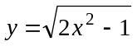. Find 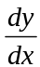.

2 marks

- Let 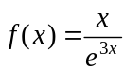. Find 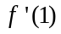.

2 marks

Question 2

Solve 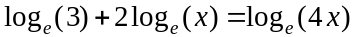 for x.

3 marks

Question 3

Let 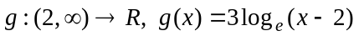.

- Find 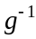, the inverse function of g.

3 marks

- If 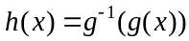, find

  - the rule for h

  - the domain of h.

Question 4

Let X be a random variable with a normal distribution with mean 10 and variance 4 and let Z be a random variable with the standard normal distribution.

- Find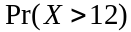.

1 mark

- Find 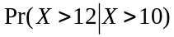.

2 marks

- Find a such that 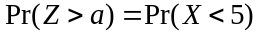.

2 marks
Question 5

Solve the equation 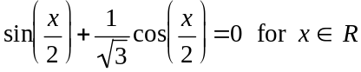.

3 marks

Question 6

At a fast food outlet, 60% of orders placed at the drive-through counter include chips. It can be assumed that an order placed by one drive-through customer is independent of an order placed by another drive-through customer.

- What is the probability that out of the next three orders placed at the drive-through counter at least two will include chips?

2 marks

- How many orders would need to have been placed at the drive-through counter
if the probability that at least one order included chips was equal to 0.84,

3 marks

Question 7

A spherical balloon is being inflated. Its volume is increasing at the rate of 2cm³ per second.
Find the rate in cm/sec, at which the radius of the balloon is increasing when the radius is 4cm.

3 marks

Question 8

Let 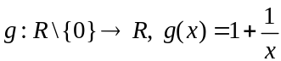.

Show that 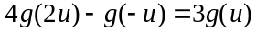.

2 marks

Question 9

Given that 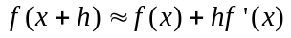, where h is small, find an approximate value of 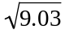.

3 marks

Question 10

Part of the graph of the function 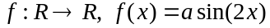 where a is a positive constant is shown below.

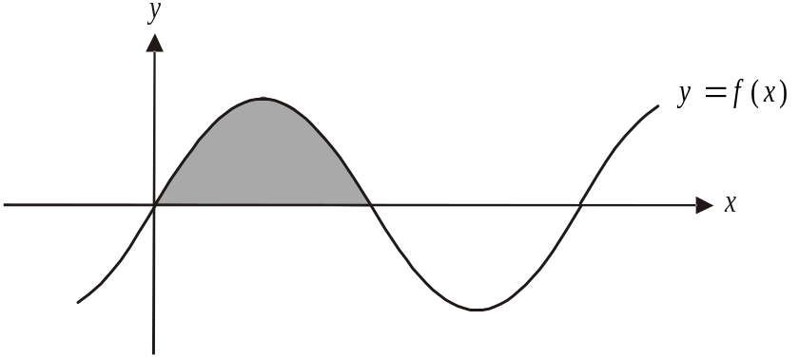

The shaded region represents an area of 4 square units.
Find the value of a.

4 marks

Question 11

Let 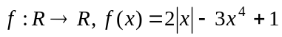.

The graph of 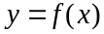 is shown below.

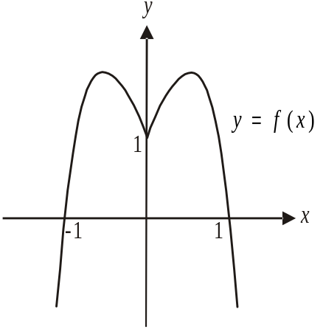

- Write down the domain of the derivative function 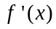.

1 mark

- Find the rule for .

2 marks

Mathematical Methods (CAS) Formulas

Mensuration

area of a trapezium: 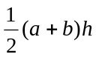 volume of a pyramid: 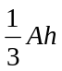
curved surface area of a cylinder: 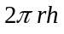 volume of a sphere: 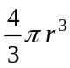
volume of a cylinder: 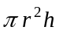 area of a triangle: 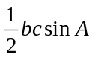
volume of a cone: 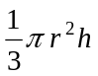

Calculus
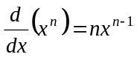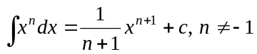
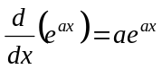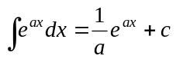
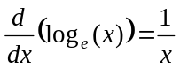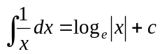
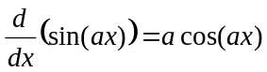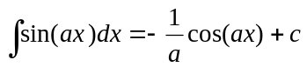
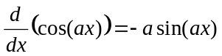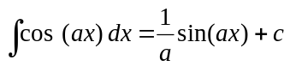
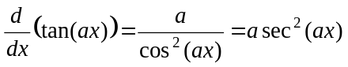
product rule: 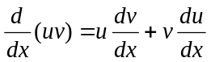 quotient rule: 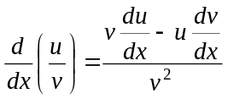
chain rule: 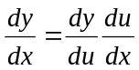 approximation:

Probability
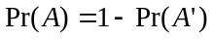
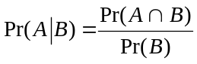 transition matrices: 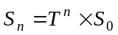
mean: 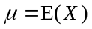 variance:

probability distribution |  | mean | variance
discrete | 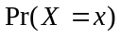=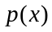 | 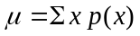 | 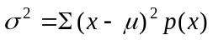
continuous | 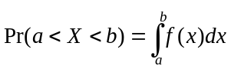 | 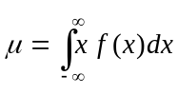 | 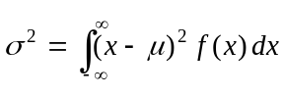

Reproduced with permission of the Victorian Curriculum and Assessment Authority, Victoria, Australia.
This formula sheet has been copied in 2011 from the VCAA website www.vcaa.vic.edu.au
The VCAA publish an exam issue supplement to the VCAA bulletin.

